1. A screenshot of a computer

   Description automatically generated
2. 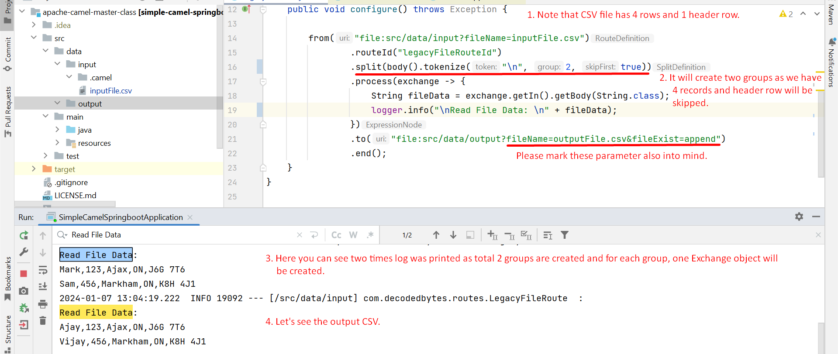
3. A screenshot of a computer

   Description automatically generated